|  |  |
| --- | --- |
| TEAM ID | PNT2022TMID50563 |
| PROJECT NAME | PROJECT-ANALYTICS FOR HOSPITAL HEALTH CARE DATA |

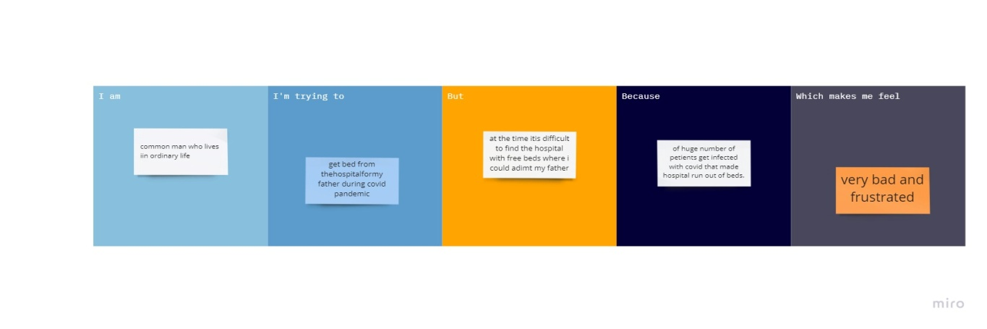

|  |  |  |  |  |  |
| --- | --- | --- | --- | --- | --- |
| Problem Statement | Iam (Customer) | I’m trying to | But | Because | Which makes me feel |
|  | common man who lives an ordinary life | get bed in a hospital for my father during covid-19 pandemic | at the time its difficult to find a hospital with free beds where i could admit my father | of huge number of patients got infected with covid-19 that made hospitals run out of beds | very bad and frustrated |
|  | a patient suffering from covid-19 | get bed in a hospital for my treatment | at this pandemic time it is difficult for me to get admitted | of huge number of patients got infected with covid-19 that made hospitals run out of beds | very bad and frustrated |